* [Home](http://food.ndtv.com/)
* [Food & Drinks](http://food.ndtv.com/food-drinks)
* 9 Incredible Benefits Of Papaya Leaf Juice

**9 Incredible Benefits of Papaya Leaf Juice**

Sushmita Sengupta  |  Updated: March 24, 2017 12:12 IST

[Tweeter](http://twitter.com/share?url=http%3A%2F%2Ffood.ndtv.com%2Ffood-drinks%2F9-incredible-benefits-of-papaya-leaf-juice-1672318)[facebook](https://www.facebook.com/sharer.php?u=http%3A%2F%2Ffood.ndtv.com%2Ffood-drinks%2F9-incredible-benefits-of-papaya-leaf-juice-1672318&text=9+Incredible+Benefits+of+Papaya+Leaf+Juice)[Google Plus](https://plus.google.com/share?url=http%3A%2F%2Ffood.ndtv.com%2Ffood-drinks%2F9-incredible-benefits-of-papaya-leaf-juice-1672318)[Reddit](http://www.reddit.com/submit)

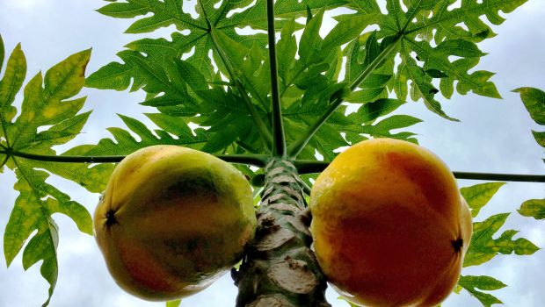Highlights

* Every part of the papaya plant can be used for multiple health benefits
* Like papaya, the leaf is also rich in enzymes like papain and chymopapain
* Papaya leaf juice increases the platelet count

Grown in the tropical regions, papaya is possibly one of the most loved fruits in the world. The yellowish orange fleshy fruit containing lots of seeds is replete with umpteen benefits. According to the book *Healing Foods*by DK Publishing House, papaya is “known to have antibacterial properties and promotes good digestion and almost every part of the plant can be used." Yes, every part! While the fruit is said to be rich in contents of vitamin E, C and beta-carotine making it loaded with antioxidant properties, the seeds are rich in fatty acids and papaya oil, have a sharp peppery flavour, and can be used in place of your spices.  
  
Papaya leaf juice, on the other hand, is also fast gaining importance in a world of nutrition for packing incredible health and skin benefits. Like the fruit, the leaf is rich in enzymes like papain and chymopapain, which aid digestion, prevents bloating and other digestive disorders. Apart from digestion, the strong alkaloid compounds like karpain works effectively against fighting dandruff and balding. Papaya leaves also contain high amounts of vitamins A, C, E, K, and B and minerals like calcium, magnesium, sodium magnesium and iron.  
  
Here is a round up of some benefits you can reap of papaya leaf juice -  
  
**1. Treats Dengue fever**  
  
A common remedy that is advised by all to dengue patients is papaya leaf juice. Dengue is caused by infected Aedes mosquitoes, who transmit the disease into our blood. [Dengue fever](http://food.ndtv.com/opinions/how-to-prevent-and-treat-dengue-6-home-remedies-1212223)severely brings down the blood platelet count, and the extracts from papaya leaf are known to help increase the count.  
Bangalore-based nutritionist, Dr. Sheela Krishnaswamy says, "Studies have proved that papaya leaf juice contributes significantly in the production of platelets and increase the platelet count."  
  
**Also Read:**[8 Amazing Benefits of Papaya for Health and Skin](http://food.ndtv.com/health/9-benefits-of-papaya-from-beauty-to-prevention-of-diseases-1213450" \t "_blank)

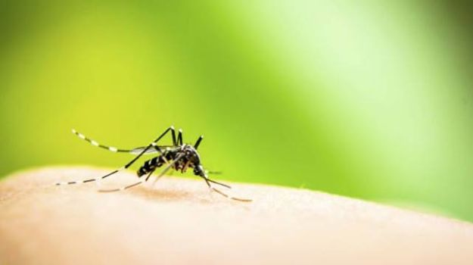

**2. Anti-Malarial Properties**  
  
[Papaya](http://food.ndtv.com/lists/10-best-papaya-recipes-1471450) leaves have strong anti-malarial properties. A compound found in papaya leaf is acetogenin, which can help prevent dangerous disease like malaria and dengue.

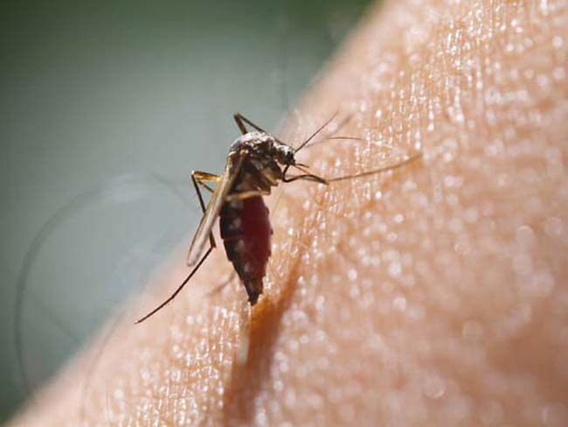

**3. Good for Liver**  
  
Just as papaya, papaya leaf juice also acts as a potent cleansing agent for the liver, thereby healing many chronic [liver diseases,](http://food.ndtv.com/health/10-cod-liver-oil-benefits-1638134) jaundice and liver cirrhosis.  
  
**4. Supports Digestion**  
  
The book *Healing Food* mentions how “papaya contains enzymes papain and chymonpapain. Both have been shown to aid digestion, [prevent constipation](http://food.ndtv.com/health/6-effective-home-remedies-for-constipation-1216545) and clean the colon. Papain is also helpful in healing and preventing stomach ulcers.”   
  
Papaya leaves are also rich in protease and amylase. These enzymes help break down proteins, carbs and minerals aiding digestion. Its high anti-inflammatory properties also reduce the inflammation of [stomach](http://food.ndtv.com/health/12-amazing-home-remedies-for-acidity-1449021) and colon. The juice can also heal peptic ulcers by killing bacteria H.Pylori owing to its antimicrobial properties. 



**5. Lowers Blood Sugar Levels**

Papaya leaf juice can work wonders for [diabetics](http://food.ndtv.com/health/beware-regular-exercises-could-worsen-type-1-diabetes-1654007) as well, as it regulates the production of insulin, which in turn checks blood sugar levels. Its strong antioxidant nature also helps to bring down the consequent complications of diabetes like kidney damage and fatty liver.  
  
**6. Cure to Your Menstrual Pain**  
  
Are you a victim of excruciating [menstrual cramps](http://food.ndtv.com/health/7-home-remedies-for-period-pain-1623302) and lower abdominal pain during your periods? Papaya leaf juice works wonders to ease the menstrual flow and reduce the pain. Drinking this juice also brings down PMS symptoms. Its potent healing properties balance hormones, and regulate menstruation cycles. You can try this concoction to treat your menstrual pain: take one papaya leaf, a pinch of salt and tamarind, mix them all in a glass of water and bring it to boil. This juice should ease your pain greatly.



**7. Helps Treat Skin Problems**  
  
Papaya leaf juice has a rich content of vitamin C and A, which boost [skin health](http://food.ndtv.com/beauty/how-to-improve-your-skin-tone-naturally-1447059) and lend you a healthier and radiant skin. Papaya leaf juice suppresses the activity of free radicals. The presence of karpain compounds checks the growth of excess micro-organisms, and cleanses your skin of the toxins, providing protection against skin problems like pimples, freckles and acne.



**8. Promotes Hair Growth**  
  
The extract of papaya leaf is said to promote hair growth, prevent balding and thinning of hair. It is an important ingredient used in [anti-dandruff](http://food.ndtv.com/beauty/neem-for-dandruff-a-natural-remedy-to-get-rid-of-it-1663826) shampoos because of the karpain compound. This alkaloid component is effective in removing dirt and oil from your scalp. It can also serve as a natural conditioner and bring back the lost sheen to your hair.



**9. Reduces Cancer Risks**  
  
Extracts from papaya leaf boasts of great anti-cancer properties majorly because of its compound acetogenin. According to the study carried by the journal of *Ethnopharmacology*, the enzymes in papaya leaf can fight liver cancer, [lung cancer,](http://food.ndtv.com/health/smoking-blocks-the-self-healing-process-in-lungs-increasing-cancer-risks-1665758) pancreatic cancer and [breast cancer](http://food.ndtv.com/health/amitabh-bachchan-launches-a-new-app-for-breast-cancer-awareness-1670101). The anti-inflammatory properties of papaya leaf could also be helpful in reducing inflammation and chemotherapy side effects.  
  
If the bitterness of the leaves bother you, you can also mix the juice with other juices like that of coconut. So don’t hold yourself back from gaining these benefits and grab some now.

*For the latest*[*food news*](http://food.ndtv.com/food-news)*,*[*health tips*](http://food.ndtv.com/health)*and*[*recipes*](http://food.ndtv.com/recipes)*, like us on [Facebook](http://facebook.com/switchtohealth/" \t "_blank) or follow us on*[*Twitter*](http://twitter.com/switchtohealth)*.*

**Tags:  [Papaya](http://food.ndtv.com/topic/papaya)**[**Papaya Leaf**](http://food.ndtv.com/topic/papaya-leaf)[**Papaya Leaf Benefits**](http://food.ndtv.com/topic/papaya-leaf-benefits)